[FanOfMySelf/CodeLoi (github.com)](https://github.com/FanOfMySelf/CodeLoi)  
  
check code này để học

US02: Custom Category Menu List (Homepage) 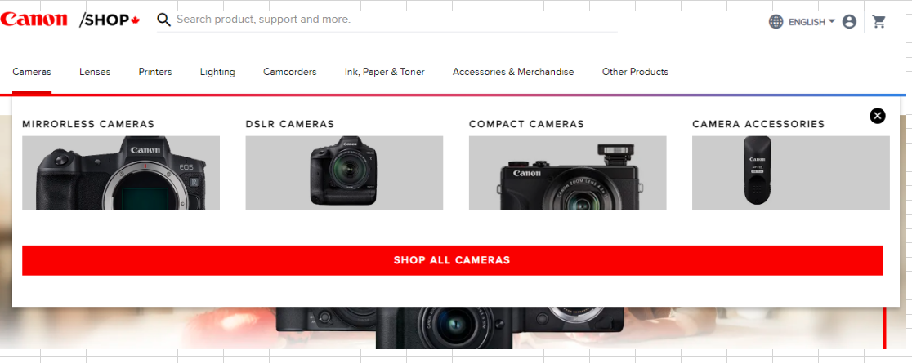

[Magento 2 – How to add custom thumbnail images in submenu items. – MilanDev.Me](http://milandev.me/magento-2-how-to-add-custom-thumbnail-images-in-submenu-items/)